AWS assignment 6

- Deploy Your flask backend and express frontend in amazon single ec2 instance.
EC2 created:
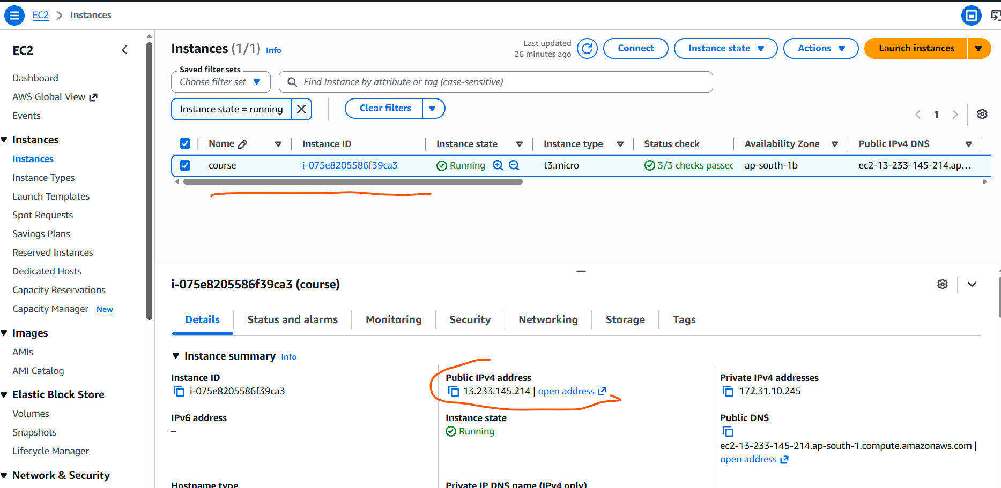

Connected to instance via SSH.
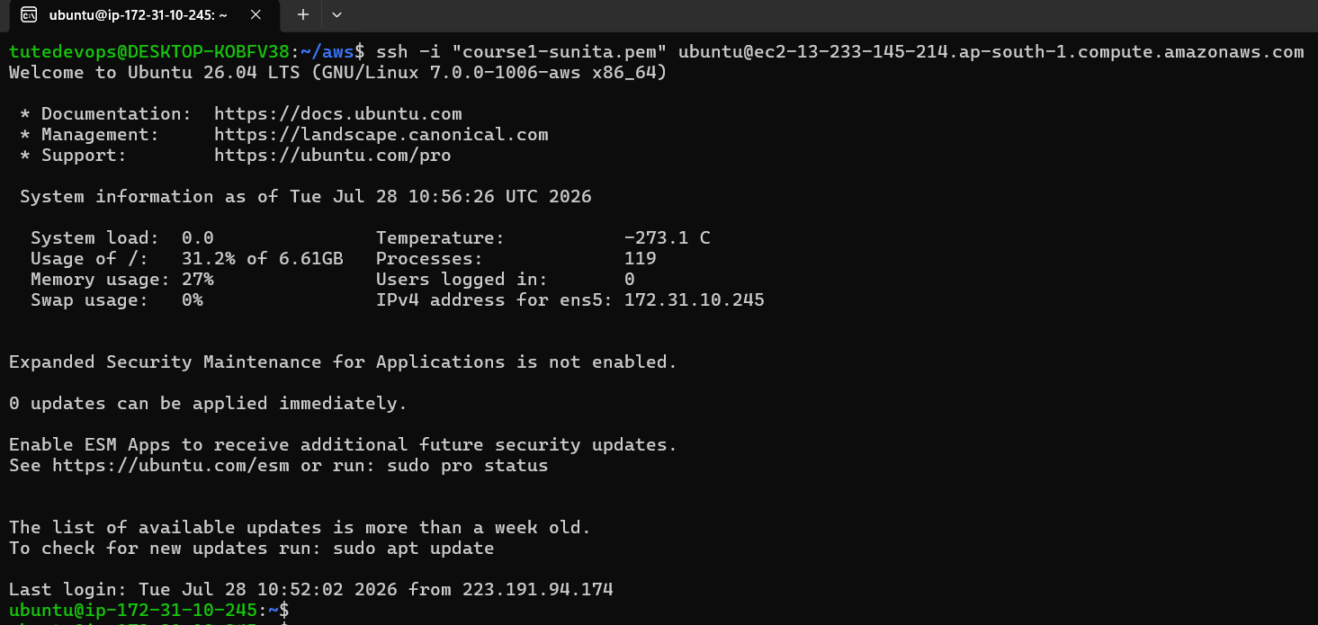

Ares-app pulled from github repository.
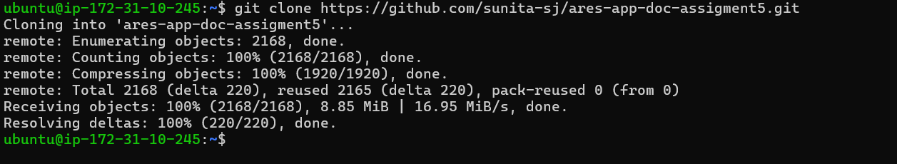

Both front end and backend in same instance:
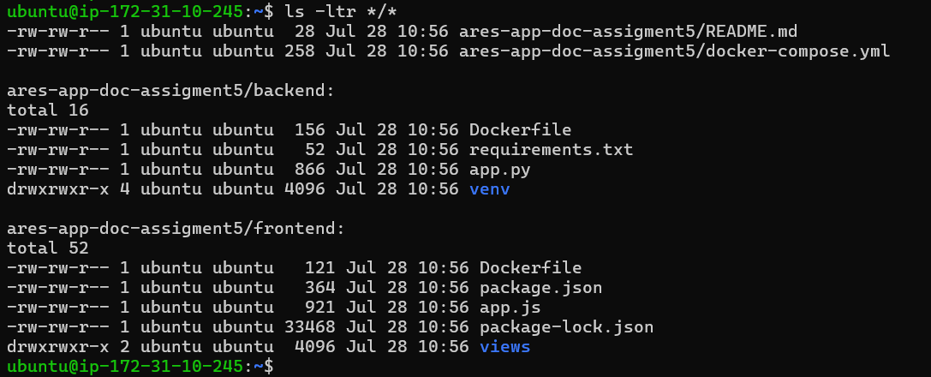

Application is running from EC2 instance.
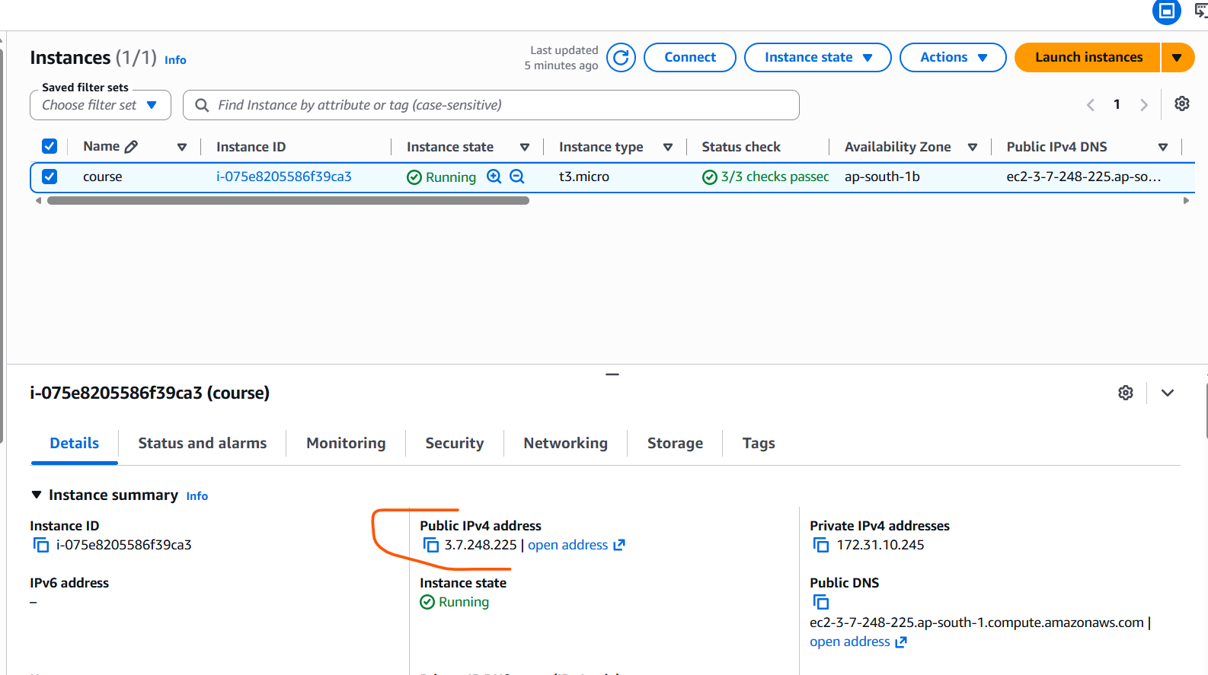
After running app.py

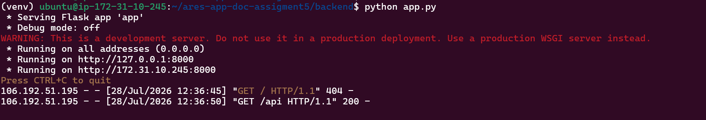
Backend tested on port 8000/api

Front end tested: port 3000

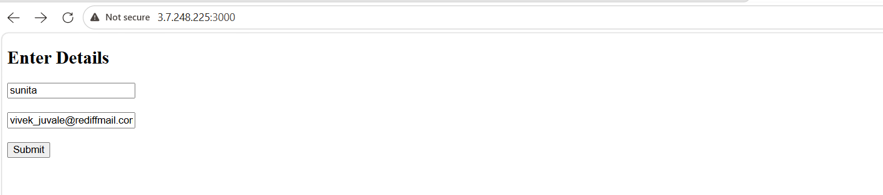
Submitted
Database entry added.
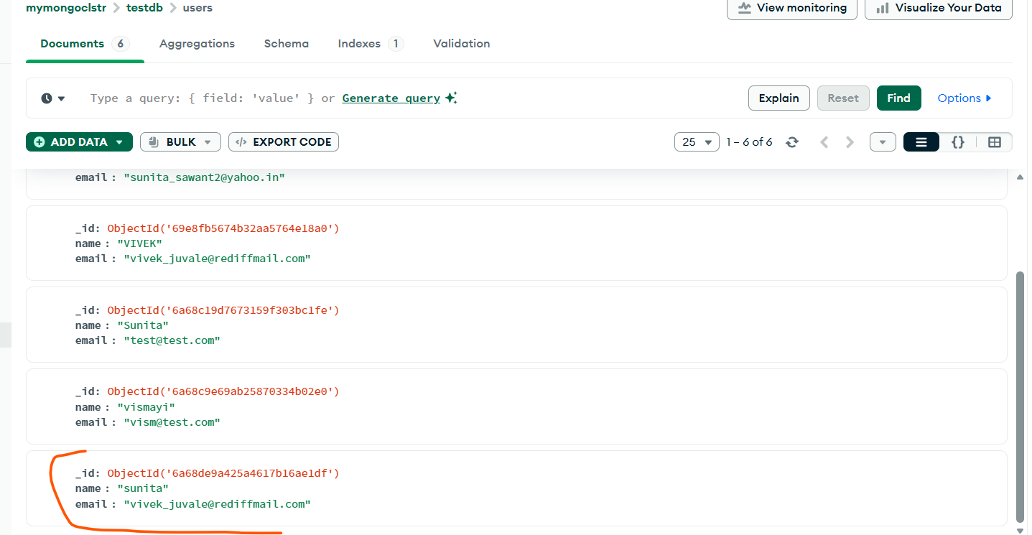

- Deploy Your flask backend and express frontend in separate ec2 instances.

Frontend ec2:

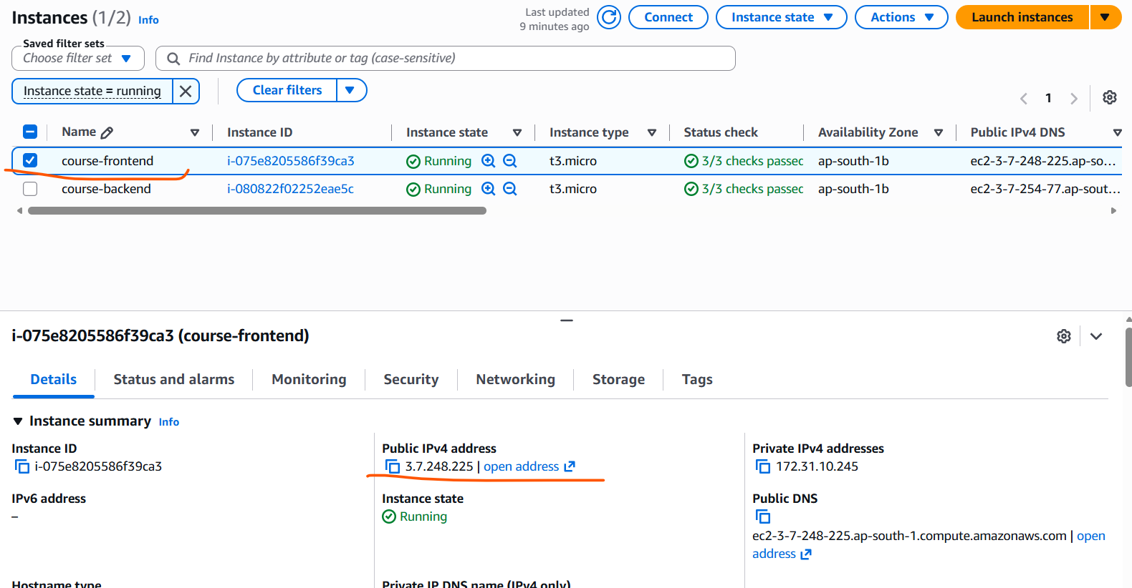

Application deployed on ec2:
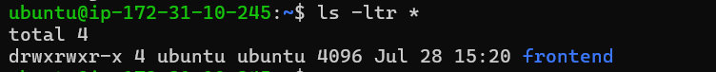

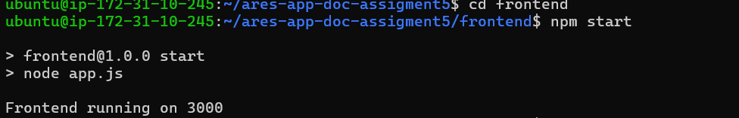

Front end tested:

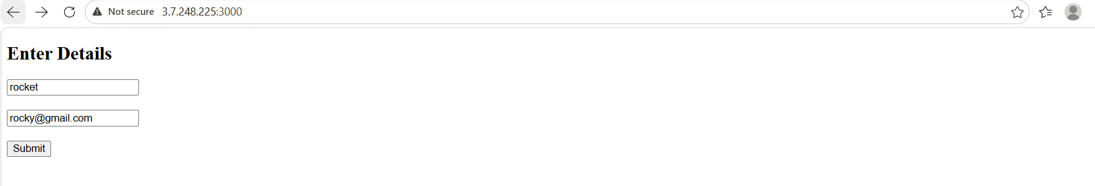

Backend Ec2:

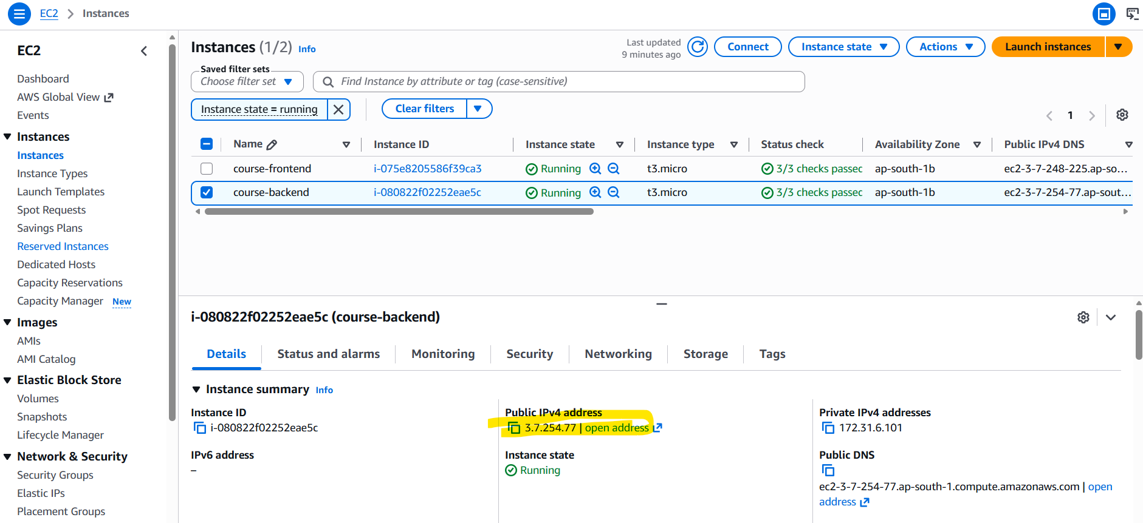

Application deployed:

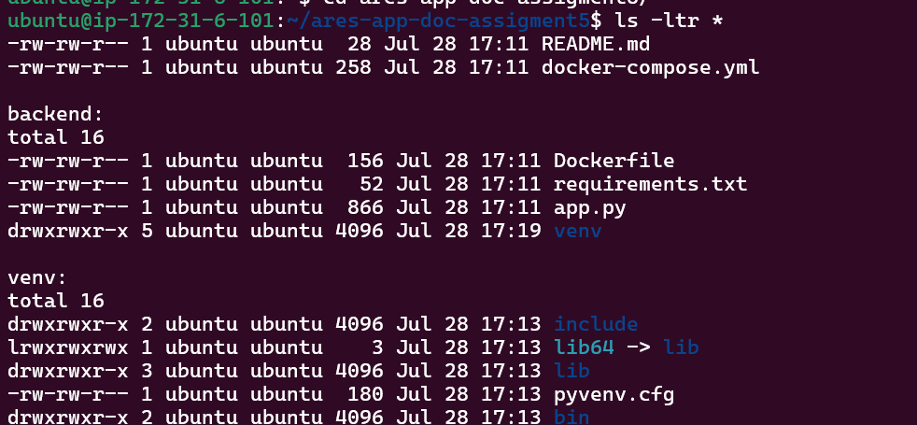

Backend response tested:

Showing last submitted entry.
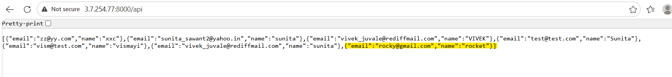

Mongo db entry:

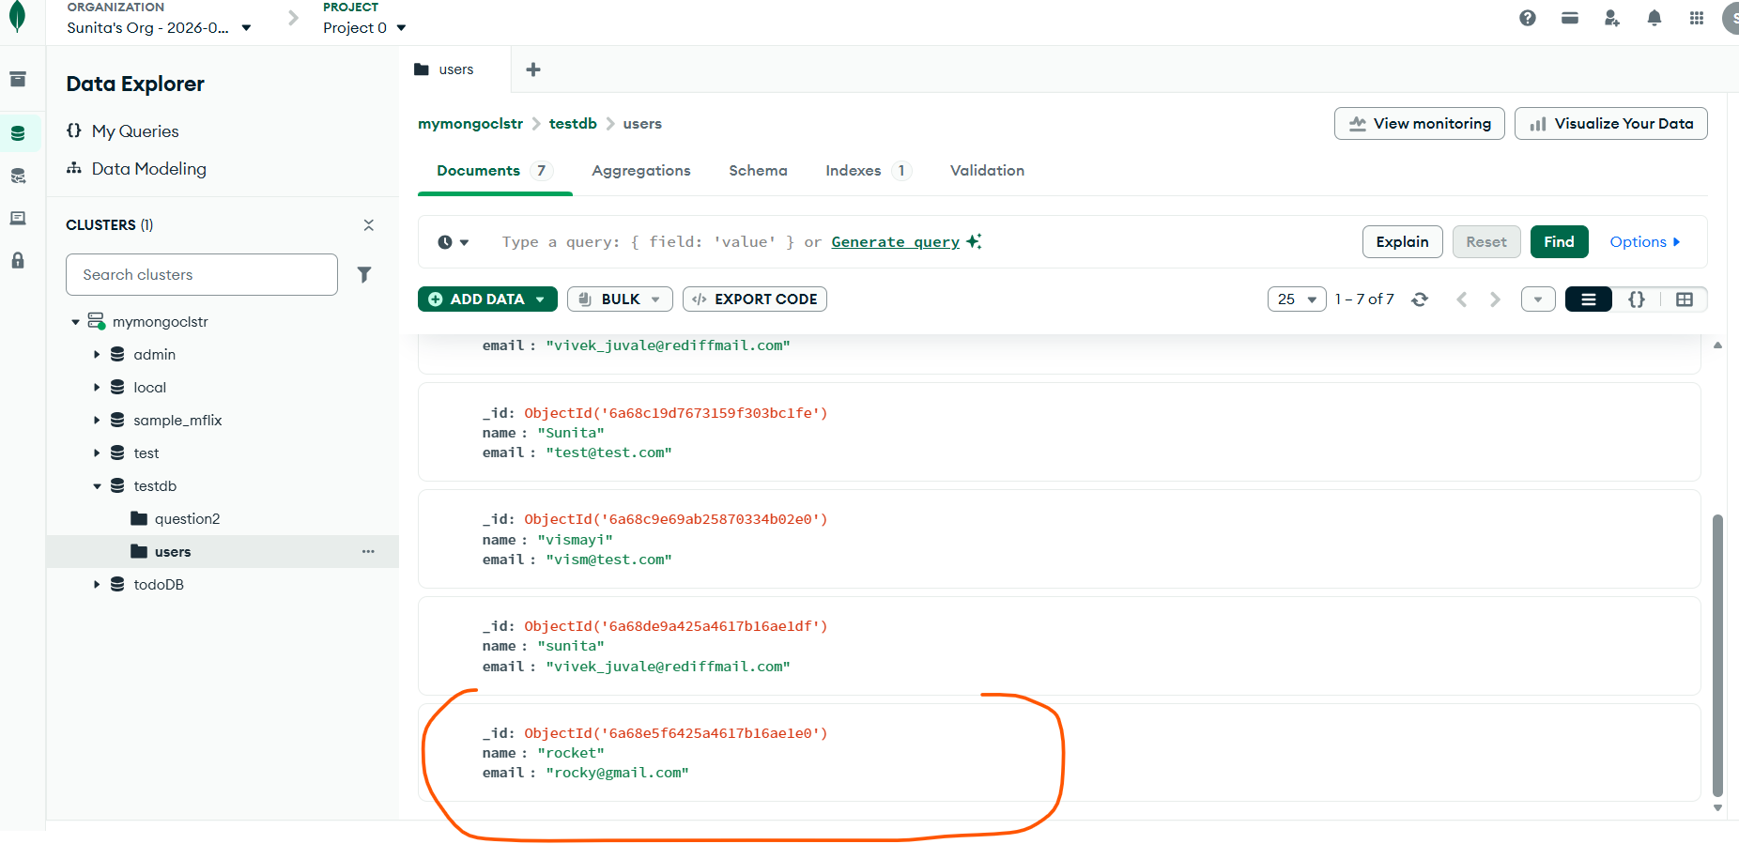

3. Deploy Your flask backend and express frontend Docker Container using aws ecr, ecs and vpc services
ECR Repository created.
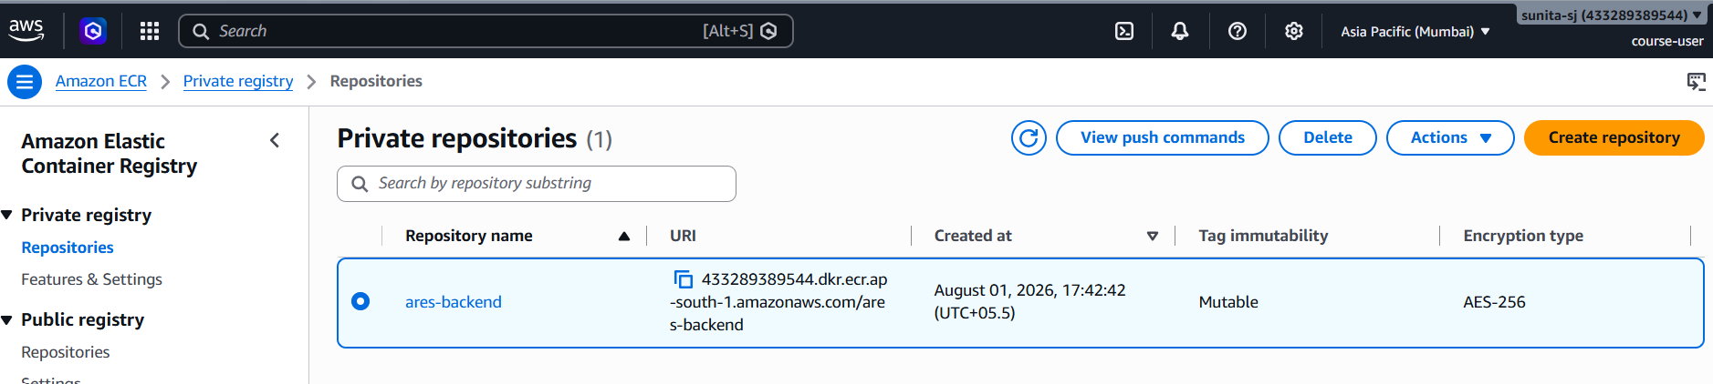

AWS connected and Docker image build for backend and pushed to repository.
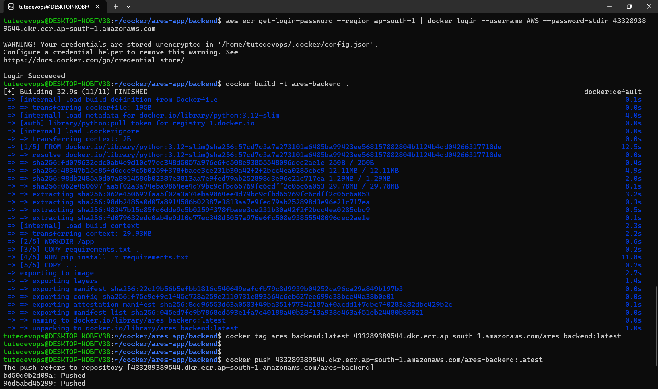
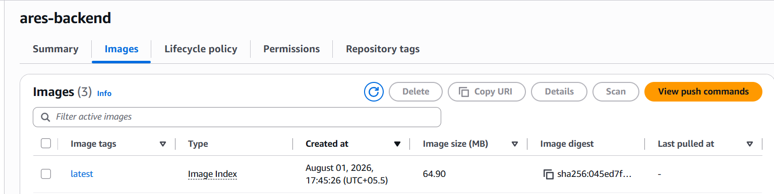

Same done for frontend as well.
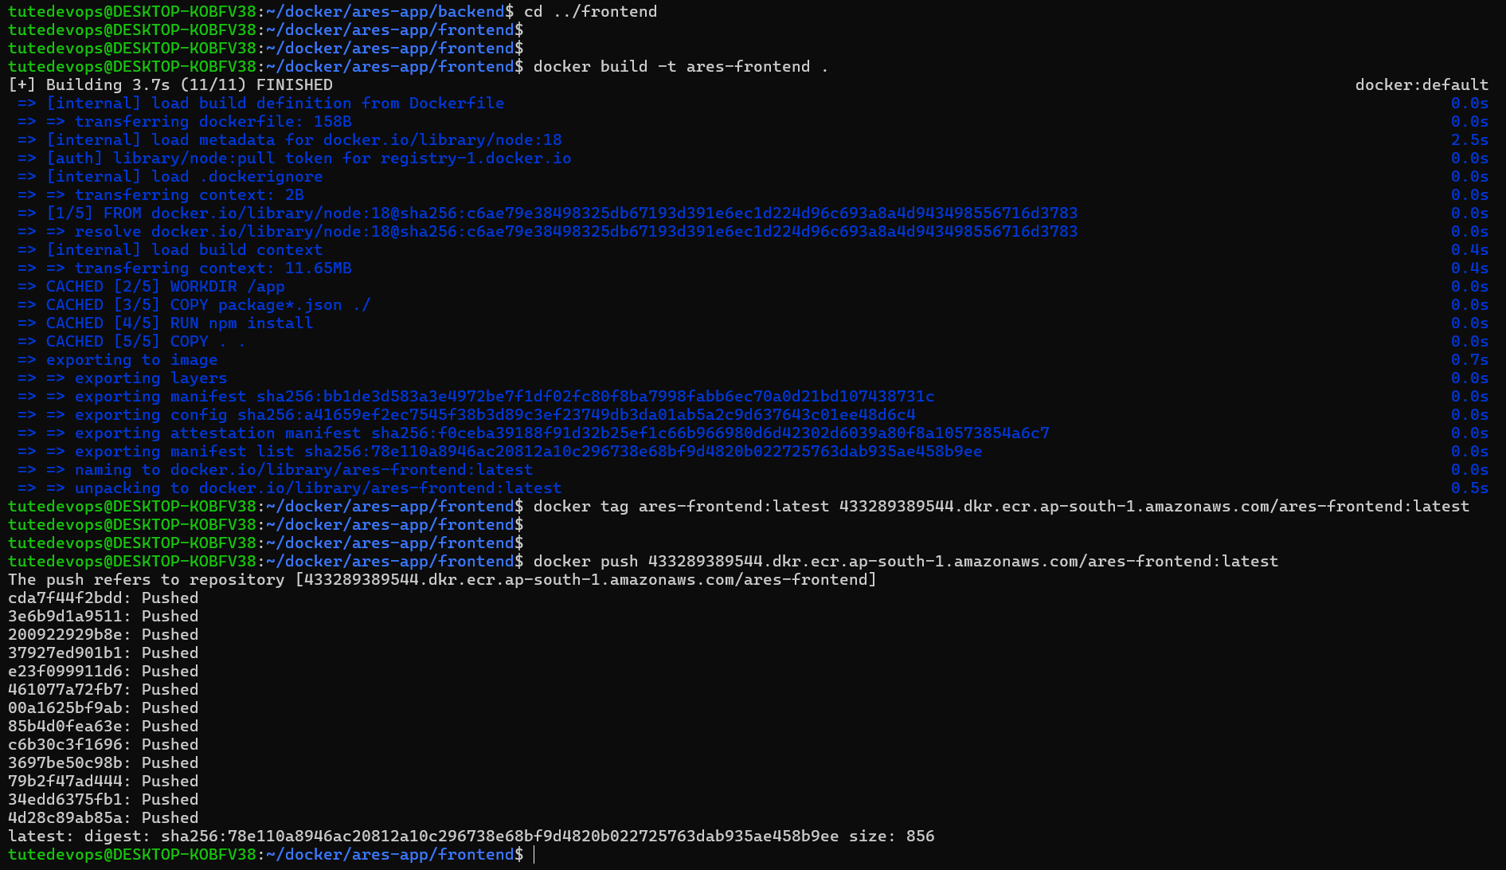
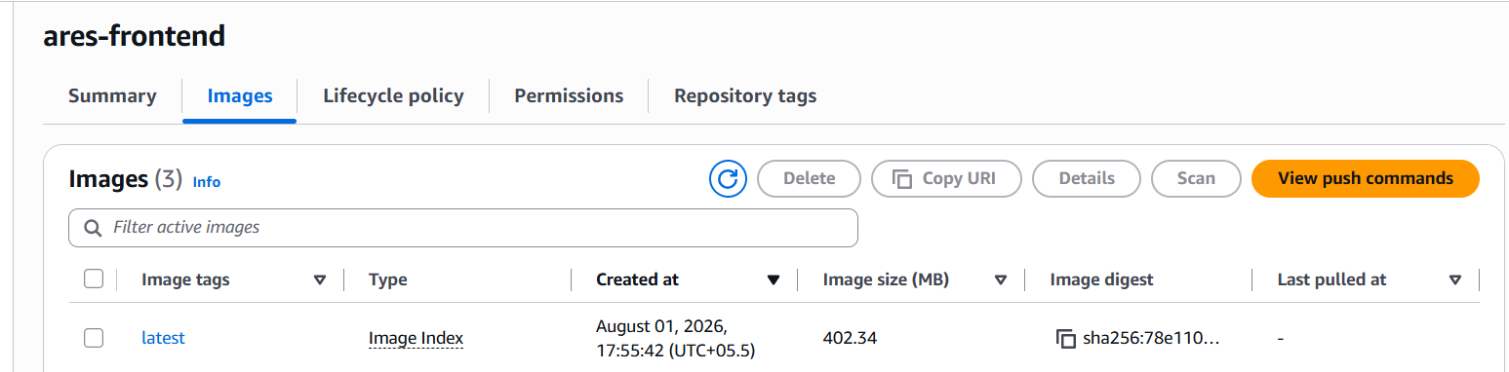

Backend tested:
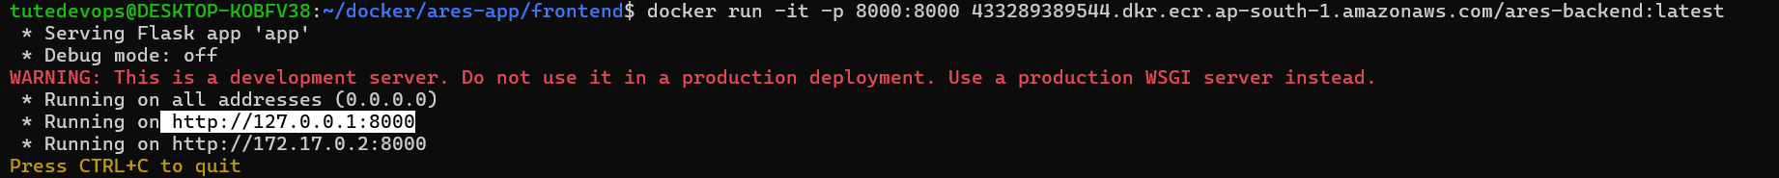
Output:

Frontend tested:
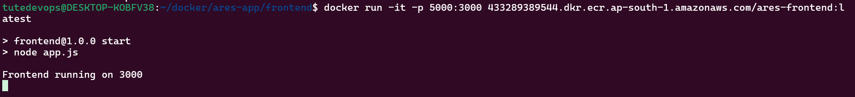
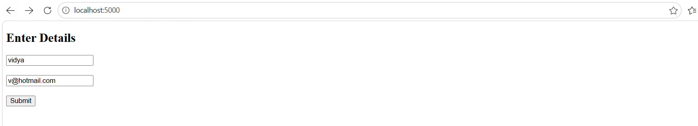

Mongodb:

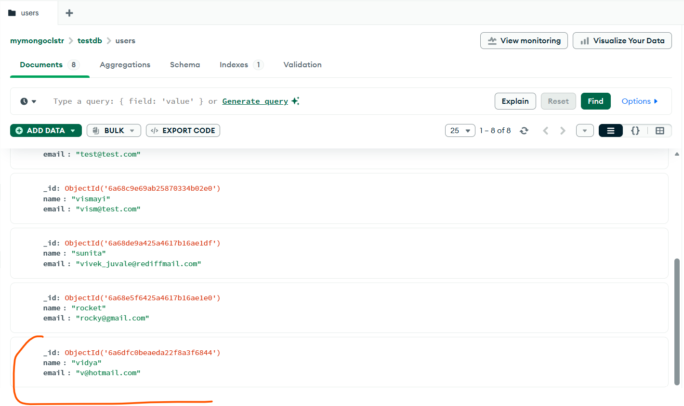

Single ECS services with two task deployed.

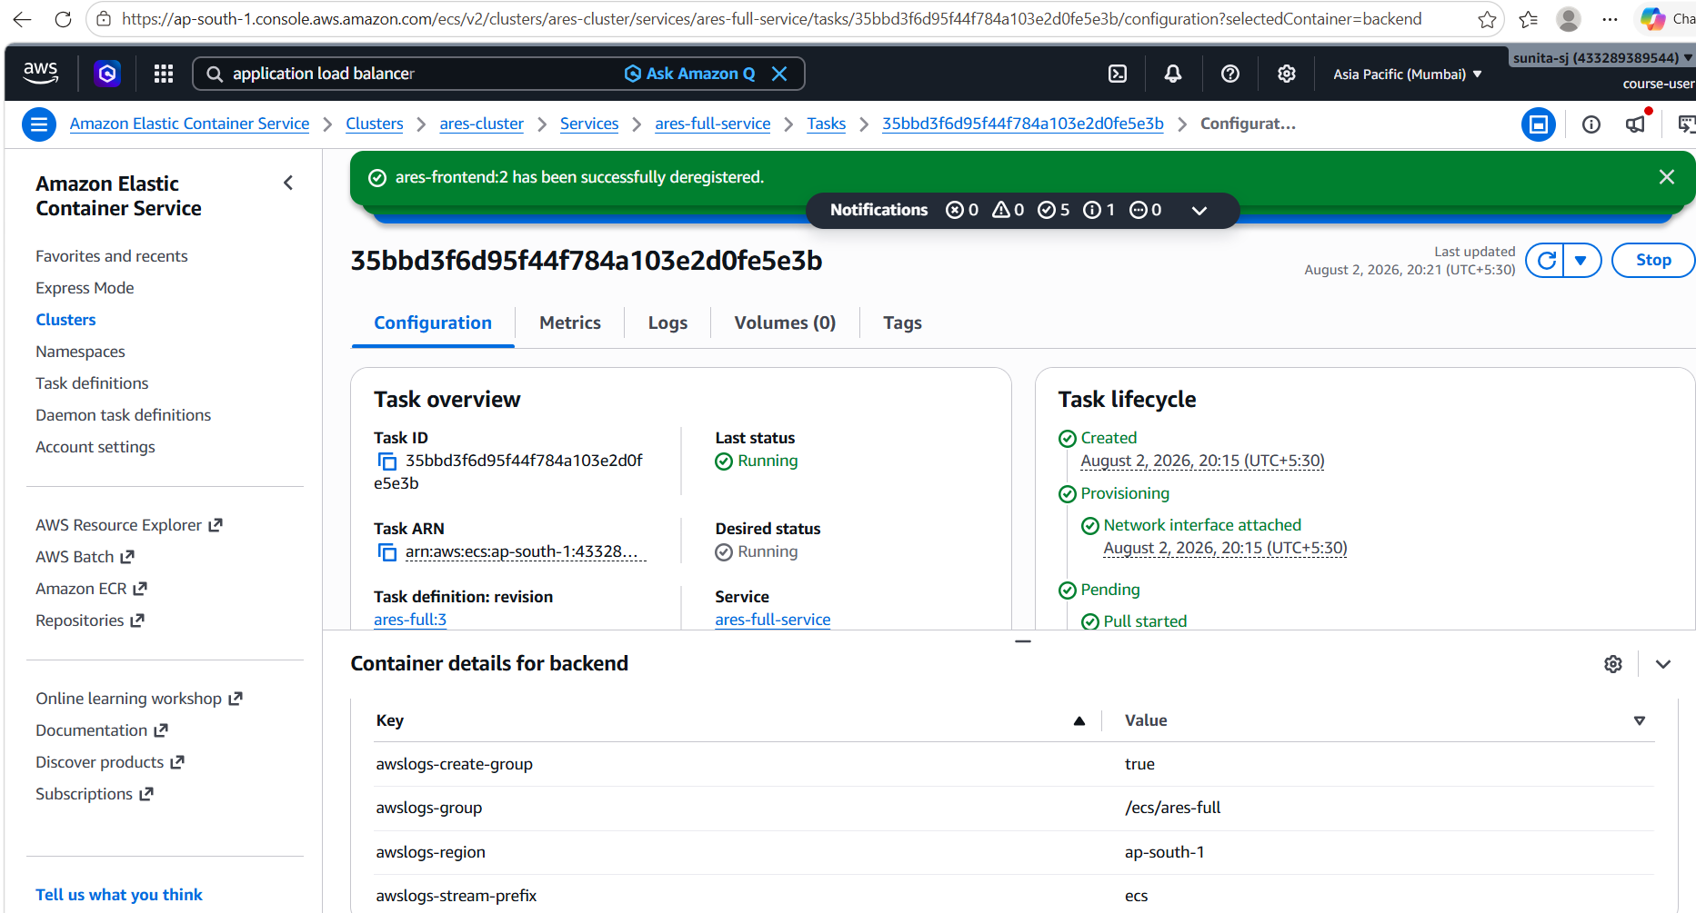

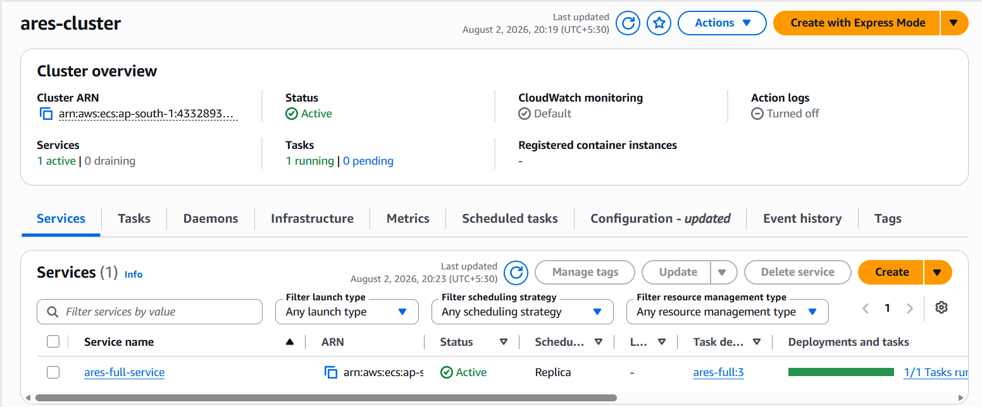

Backend tested:

Frontend:
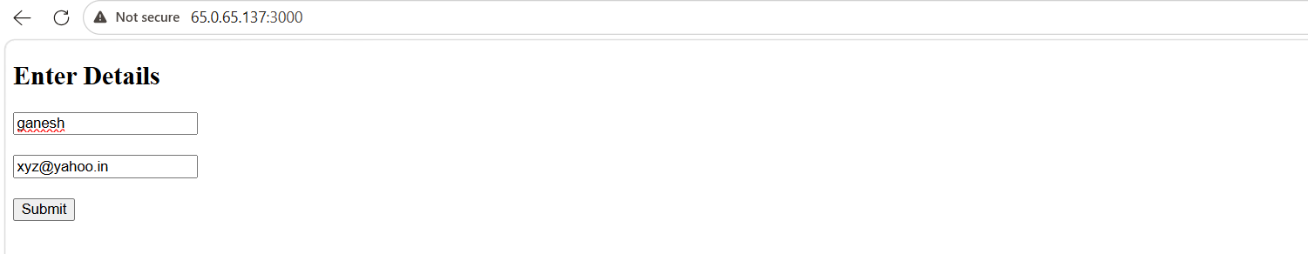
Mongodb entry:
